* **CAREER OBJECTIVE**

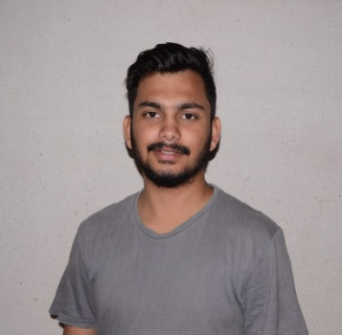

* **ACADEMIC DETAILS**
* Bachelor of Technology(B-Tech), Mechanical Engineering (2017-2021)

REVA University.

* 12th

Year of completion-2017

CBSE board (SAINIK SCHOOL-KODAGU)

Percentage: 66.00%

* 10th

Year of completion-2015

CBSE Board (SAINIK SCHOOL-KODAGU)

CGPA: 9.0

**SHARANABASAV**

**DATE**: 07/02/2021

* **SHARANABASAV**

**■ DECLARATION**: I declare that information given above is true to the best of my knowledge.

Name : SHARANABASAV

Nationality : Indian

Date of Birth : 20/11/1999

Languages Known : Kannada, English, Hindi

Home Town : Bidar, Karnataka

Mobile no. : 8762691306

Email ID: sharabasavpatil306306@gmail.com

* Reading finance books
* Playing football
* Analysis of balance sheet
* Watching biography movies
* Reading spiritual books
* Travelling
* **Hobbies**
* Programming language:-
* C language
* C++
* Python (Beginner)
* Basic knowledge of Internet of things (IOT)

Mask vending machine. (This project helps in placing the mask vending machines near college ,school, office or hospital entrance to maintain hygiene and sanitation.

* **TECHNICAL SKILLS**
* **PERSONAL PROFILE**
* Strong leadership and motivational skills.
* Ability to handle pressure
* Team work
* Event management
* Willingness to learn new things
* **CORE STRENGTHS**

To seek challenging avenue where my knowledge and skills will be utilized and enable me to improve further and contribute to success and growth of the organization.

* **PROJECTS**